Christmas Guide 2024

Readings for Christmas Eve

for Christmas Day &

the Holiday Season

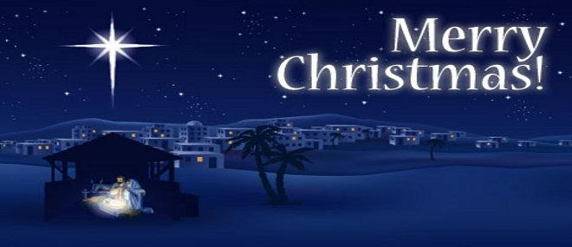

Compiled for you by

Pastor John Rosol

Indian Hill Bible Church



Dear Friend in Christ,

Christmas is a most joyous time of year. While one can find joy in many things, there is a special kind of joy that one can only find in Jesus Christ - reason for the season! This book is set up with various biblical passages that tell the story of Christmas, so you can learn and meditate on the incredible story of Jesus Christ. The One who is our Lord, Savior & King!

Readings for Christmas Eve Morning

**Isaiah 7:13–14** (KJV)

13 And he said, Hear ye now, O house of David; *Is it* a small thing for you to weary men, but will ye weary my God also?

14 Therefore the Lord himself shall give you a sign;

Behold, a virgin shall conceive, and bear a son,

And shall call his name Immanuel.

**Isaiah 9:6-7** (KJV)

6  For unto us a child is born, unto us a son is given:

And the government shall be upon his shoulder:

And his name shall be called Wonderful, Counseller, The mighty God, The everlasting Father, The Prince of Peace.

7  Of the increase of his government and peace there shall be no end, Upon the throne of David, and upon his kingdom,

To order it, and to establish it with judgment and with justice

From henceforth even forever. The zeal of the Lord of hosts will perform this.

**Micah 5:2** (KJV)

2 But thou, Beth-lehem Ephratah, *Though* thou be little among the thousands of Judah, *Yet* out of thee shall he come forth unto me *that is* to be ruler in Israel; Whose goings forth *have been* from of old, from everlasting.

**Isaiah 40:1-5, 9** (NASB95)

**1** “Comfort, yes, comfort My people!”

Says your God.

2 “Speak comfort to Jerusalem, and cry out to her,

That her warfare is ended,

That her iniquity is pardoned;

For she has received from the Lord’s hand

Double for all her sins.”

3 The voice of one crying in the wilderness:

“Prepare the way of the Lord;

Make straight in the desert

A highway for our God.

4 Every valley shall be exalted

And every mountain and hill brought low;

The crooked places shall be made straight

And the rough places smooth;

5 The glory of the Lord shall be revealed,

And all flesh shall see *it* together;

For the mouth of the Lord has spoken.”

9 O Zion,

You who bring good tidings,

Get up into the high mountain;

O Jerusalem,

You who bring good tidings,

Lift up your voice with strength,

Lift *it* up, be not afraid;

Say to the cities of Judah, “Behold your God!”

**Hebrews 1:1–2** (NASB95)

**1** God, after He spoke long ago to the fathers in the prophets in many portions and in many ways,

2 in these last days has spoken to us in His Son, whom He appointed heir of all things, through whom also He made the world.

Readings for the evening of

Christmas Eve

**Luke 1:26–56** (NASB95)

**26** Now in the sixth month the angel Gabriel was sent from God to a city in Galilee called Nazareth,

27 to a virgin engaged to a man whose name was Joseph, of the descendants of David; and the virgin’s name was Mary.

28 And coming in, he said to her, “Greetings, favored one! The Lord *is* with you.”

29 But she was very perplexed at *this* statement, and kept pondering what kind of salutation this was.

30 The angel said to her, “Do not be afraid, Mary; for you have found favor with God.

31 “And behold, you will conceive in your womb and bear a son, and you shall name Him Jesus.

32 “He will be great and will be called the Son of the Most High; and the Lord God will give Him the throne of His father David;

33 and He will reign over the house of Jacob forever, and His kingdom will have no end.”

34 Mary said to the angel, “How can this be, since I am a virgin?”

35 The angel answered and said to her, “The Holy Spirit will come upon you, and the power of the Most High will overshadow you; and for that reason the holy Child shall be called the Son of God.

36 “And behold, even your relative Elizabeth has also conceived a son in her old age; and she who was called barren is now in her sixth month.

37 “For nothing will be impossible with God.”

38 And Mary said, “Behold, the bondslave of the Lord; may it be done to me according to your word.” And the angel departed from her.

*Mary Visits Elizabeth*

**39** Now at this time Mary arose and went in a hurry to the hill country, to a city of Judah,

40 and entered the house of Zacharias and greeted Elizabeth.

41 When Elizabeth heard Mary’s greeting, the baby leaped in her womb; and Elizabeth was filled with the Holy Spirit.

42 And she cried out with a loud voice and said, “Blessed *are* you among women, and blessed *is* the fruit of your womb!

43 “And how has it *happened* to me, that the mother of my Lord would come to me?

44 “For behold, when the sound of your greeting reached my ears, the baby leaped in my womb for joy.

45 “And blessed *is* she who believed that there would be a fulfillment of what had been spoken to her by the Lord.”

*The Magnificat*

**46** And Mary said: “My soul exalts the Lord,

47 And my spirit has rejoiced in God my Savior.

48 “For He has had regard for the humble state of His bondslave

For behold, from this time on all generations will count me blessed.

49 “For the Mighty One has done great things for me; And holy is His name.

50 “And His mercy is upon generation after generation Toward those who fear Him.

51 “He has done mighty deeds with His arm; He has scattered *those who were* proud in the thoughts of their heart.

52 “He has brought down rulers from *their* thrones, And has exalted those who were humble.

53 “He has filled the hungry with good things; And sent away the rich empty-handed.

54 “He has given help to Israel His servant, In remembrance of His mercy,

55 As He spoke to our fathers, To Abraham and his descendants forever.”

**56** And Mary stayed with her about three months, and *then* returned to her home.

**Luke 2:1–20** (NASB95) *Jesus’ Birth in Bethlehem*

**1** Now in those days a decree went out from Caesar Augustus, that a census be taken of all the inhabited earth.

2 This was the first census taken while Quirinius was governor of Syria.

3 And everyone was on his way to register for the census, each to his own city.

4 Joseph also went up from Galilee, from the city of Nazareth, to Judea, to the city of David which is called Bethlehem, because he was of the house and family of David,

5 in order to register along with Mary, who was engaged to him, and was with child.

6 While they were there, the days were completed for her to give birth.

7 And she gave birth to her firstborn son; and she wrapped Him in cloths, and laid Him in a manger, because there was no room for them in the inn.

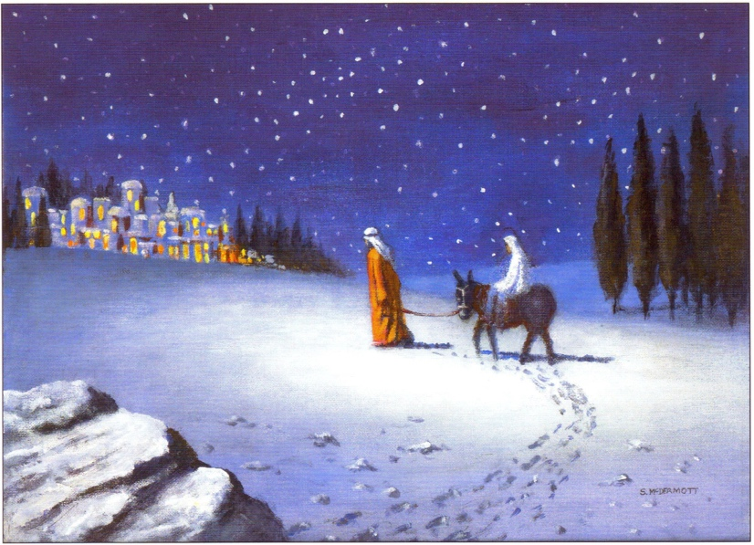

**8** In the same region there were *some* shepherds staying out in the fields and keeping watch over their flock by night.

9 And an angel of the Lord suddenly stood before them, and the glory of the Lord shone around them; and they were terribly frightened.

10 But the angel said to them, “Do not be afraid; for behold, I bring you good news of great joy which will be for all the people;

11 for today in the city of David there has been born for you a Savior, who is Christ the Lord.

12 “This *will be* a sign for you: you will find a baby wrapped in cloths and lying in a manger.”

13 And suddenly there appeared with the angel a multitude of the heavenly host praising God and saying,

14 “Glory to God in the highest, And on earth peace among men with whom He is pleased.”

**15** When the angels had gone away from them into heaven, the shepherds *began* saying to one another, “Let us go straight to Bethlehem then, and see this thing that has happened which the Lord has made known to us.”

16 So they came in a hurry and found their way to Mary and Joseph, and the baby as He lay in the manger.

17 When they had seen this, they made known the statement which had been told them about this Child.

18 And all who heard it wondered at the things which were told them by the shepherds.

19 But Mary treasured all these things, pondering them in her heart.

20 The shepherds went back, glorifying and praising God for all that they had heard and seen, just as had been told them.

Readings for Christmas Day

Matthew 1:18–25 (NASB95) *Conception and Birth of Jesus*

**18** Now the birth of Jesus Christ was as follows: when His mother Mary had been betrothed to Joseph, before they came together she was found to be with child by the Holy Spirit.

19 And Joseph her husband, being a righteous man and not wanting to disgrace her, planned to send her away secretly.

20 But when he had considered this, behold, an angel of the Lord appeared to him in a dream, saying, “Joseph, son of David, do not be afraid to take Mary as your wife; for the Child who has been conceived in her is of the Holy Spirit.

21 “She will bear a Son; and you shall call His name Jesus, for He will save His people from their sins.”

22 Now all this took place to fulfill what was spoken by the Lord through the prophet:

23 “Behold, the virgin shall be with child and shall bear a Son, and they shall call His name Immanuel,” which translated means, “God with us.”

24 And Joseph awoke from his sleep and did as the angel of the Lord commanded him, and took *Mary* as his wife,

25 but kept her a virgin until she gave birth to a Son; and he called His name Jesus.

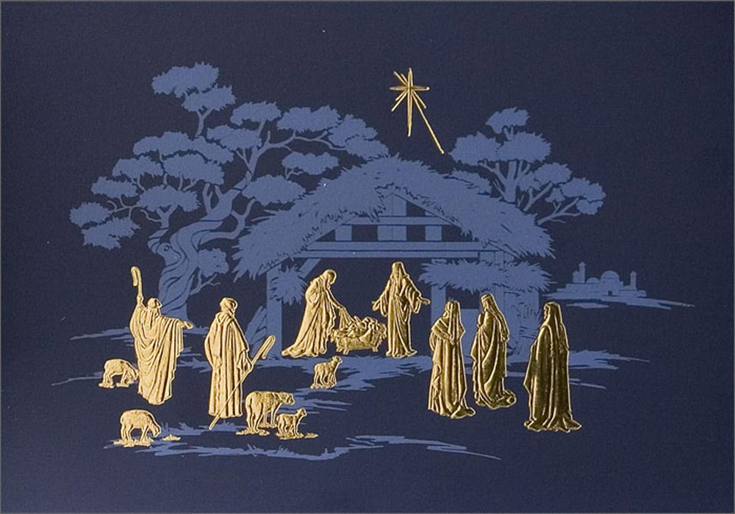

**Matthew 2:1-23** (NASB95) *The Visit of the Magi*

**1** Now after Jesus was born in Bethlehem of Judea in the days of Herod the king, magi from the east arrived in Jerusalem, saying,

2 “Where is He who has been born King of the Jews? For we saw His star in the east and have come to worship Him.”

3 When Herod the king heard *this*, he was troubled, and all Jerusalem with him.

4 Gathering together all the chief priests and scribes of the people, he inquired of them where the Messiah was to be born.

5 They said to him, “In Bethlehem of Judea; for this is what has been written by the prophet:

6 ‘And you, Bethlehem, land of Judah,

Are by no means least among the leaders of Judah;

For out of you shall come forth a Ruler

Who will shepherd My people Israel.’ ”

**7** Then Herod secretly called the magi and determined from them the exact time the star appeared.

8 And he sent them to Bethlehem and said, “Go and search carefully for the Child; and when you have found *Him,* report to me, so that I too may come and worship Him.”

9 After hearing the king, they went their way; and the star, which they had seen in the east, went on before them until it came and stood over *the place* where the Child was.

10 When they saw the star, they rejoiced exceedingly with great joy.

11 After coming into the house they saw the Child with Mary His mother; and they fell to the ground and worshiped Him. Then, opening their treasures, they presented to Him gifts of gold, frankincense, and myrrh.

12 And having been warned *by God* in a dream not to return to Herod, the magi left for their own country by another way.

*The Flight to Egypt*

**13** Now when they had gone, behold, an angel of the Lord appeared to Joseph in a dream and said, “Get up! Take the Child and His mother and flee to Egypt and remain there until I tell you; for Herod is going to search for the Child to destroy Him.”

**14** So Joseph got up and took the Child and His mother while it was still night and left for Egypt.

15 He remained there until the death of Herod. *This was* to fulfill what had been spoken by the Lord through the prophet: “Out of Egypt I called My Son.”

**16** Then when Herod saw that he had been tricked by the magi, he became very enraged, and sent and slew all the male children who were in Bethlehem and all its vicinity, from two years old and under, according to the time which he had determined from the magi.

17 Then what had been spoken through Jeremiah the prophet was fulfilled:

18 “A voice was heard in Ramah, Weeping and great mourning,

Rachel weeping for her children; And she refused to be comforted,

Because they were no more.”

**19** But when Herod died, behold, an angel of the Lord appeared in a dream to Joseph in Egypt, and said,

20 “Get up, take the Child and His mother, and go into the land of Israel; for those who sought the Child’s life are dead.”

21 So Joseph got up, took the Child and His mother, and came into the land of Israel.

22 But when he heard that Archelaus was reigning over Judea in place of his father Herod, he was afraid to go there. Then after being warned *by God* in a dream, he left for the regions of Galilee,

23 and came and lived in a city called Nazareth. *This was* to fulfill what was spoken through the prophets: “He shall be called a Nazarene.”

**John 1:1–18** (NASB95) *The Deity of Jesus Christ*

**1** In the beginning was the Word, and the Word was with God, and the Word was God.

2 He was in the beginning with God.

3 All things came into being through Him, and apart from Him nothing came into being that has come into being.

4 In Him was life, and the life was the Light of men.

5 The Light shines in the darkness, and the darkness did not comprehend it.

**6** There came a man sent from God, whose name was John.

7 He came as a witness, to testify about the Light, so that all might believe through him.

8 He was not the Light, but *he came* to testify about the Light.

**9** There was the true Light which, coming into the world, enlightens every man.

10 He was in the world, and the world was made through Him, and the world did not know Him.

11 He came to His own, and those who were His own did not receive Him.

12 But as many as received Him, to them He gave the right to become children of God, *even* to those who believe in His name,

13 who were born, not of blood nor of the will of the flesh nor of the will of man, but of God.

*The Word Made Flesh*

**14** And the Word became flesh, and dwelt among us, and we saw His glory, glory as of the only begotten from the Father, full of grace and truth.

15 John testified about Him and cried out, saying, “This was He of whom I said, ‘He who comes after me has a higher rank than I, for He existed before me.’ ”

16 For of His fullness we have all received, and grace upon grace.

17 For the Law was given through Moses; grace and truth were realized through Jesus Christ.

18 No one has seen God at any time; the only begotten God who is in the bosom of the Father, He has explained *Him.*

Additional Readings for Christmas

**Luke 2:21–38** (NASB95) *Jesus Presented at the Temple*

**21** And when eight days had passed, before His circumcision, His name was *then* called Jesus, the name given by the angel before He was conceived in the womb.

**22** And when the days for their purification according to the law of Moses were completed, they brought Him up to Jerusalem to present Him to the Lord

23 (as it is written in the Law of the Lord, “Every *firstborn* male that opens the womb shall be called holy to the Lord”),

24 and to offer a sacrifice according to what was said in the Law of the Lord, “A pair of turtledoves or two young pigeons.”

**25** And there was a man in Jerusalem whose name was Simeon; and this man was righteous and devout, looking for the consolation of Israel; and the Holy Spirit was upon him.

26 And it had been revealed to him by the Holy Spirit that he would not see death before he had seen the Lord’s Christ.

27 And he came in the Spirit into the temple; and when the parents brought in the child Jesus, to carry out for Him the custom of the Law,

28 then he took Him into his arms, and blessed God, and said,

29 “Now Lord, You are releasing Your bond-servant to depart in peace, According to Your word;

30 For my eyes have seen Your salvation,

31 Which You have prepared in the presence of all peoples,

32 A Light of revelation to the Gentiles,

And the glory of Your people Israel.”

**33** And His father and mother were amazed at the things which were being said about Him.

34 And Simeon blessed them and said to Mary His mother, “Behold, this *Child* is appointed for the fall and rise of many in Israel, and for a sign to be opposed—

35 and a sword will pierce even your own soul—to the end that thoughts from many hearts may be revealed.”

**36** And there was a prophetess, Anna the daughter of Phanuel, of the tribe of Asher. She was advanced in years and had lived with *her* husband seven years after her marriage,

37 and then as a widow to the age of eighty-four. She never left the temple, serving night and day with fastings and prayers.

38 At that very moment she came up and *began* giving thanks to God, and continued to speak of Him to all those who were looking for the redemption of Jerusalem.

**Philippians 2:5–11** (NASB95)

5 Have this attitude in yourselves which was also in Christ Jesus,

6 who, although He existed in the form of God, did not regard equality with God a thing to be grasped,

7 but emptied Himself, taking the form of a bond-servant, *and* being made in the likeness of men.

8 Being found in appearance as a man, He humbled Himself by becoming obedient to the point of death, even death on a cross.

9 For this reason also, God highly exalted Him, and bestowed on Him the name which is above every name,

10 so that at the name of Jesus every knee will bow, of those who are in heaven and on earth and under the earth,

11 and that every tongue will confess that Jesus Christ is Lord, to the glory of God the Father.

**Hebrews 1:1–4** (NASB95) *God’s Final Word in His Son*

**1** God, after He spoke long ago to the fathers in the prophets in many portions and in many ways,

2 in these last days has spoken to us in His Son, whom He appointed heir of all things, through whom also He made the world.

3 And He is the radiance of His glory and the exact representation of His nature, and upholds all things by the word of His power. When He had made purification of sins, He sat down at the right hand of the Majesty on high,

4 having become as much better than the angels, as He has inherited a more excellent name than they.

Additional Readings for Christmas

and the Holiday Season on Salvation

**2 Corinthians 5:20–21** (NASB95)

**20** Therefore, we are ambassadors for Christ, as though God were making an appeal through us; we beg you on behalf of Christ, be reconciled to God.

21 He made Him who knew no sin *to be* sin on our behalf, so that we might become the righteousness of God in Him.

**1 Peter 2:21–25** (NASB95)

21 For you have been called for this purpose, since Christ also suffered for you, leaving you an example for you to follow in His steps,

22 who committed no sin, nor was any deceit found in His mouth;

23 and while being reviled, He did not revile in return; while suffering, He uttered no threats, but kept entrusting *Himself* to Him who judges righteously;

24 and He Himself bore our sins in His body on the cross, so that we might die to sin and live to righteousness; for by His wounds you were healed.

25 For you were continually straying like sheep, but now you have returned to the Shepherd and Guardian of your souls.

**John 3:16–19 (**NASB95)

**16** “For God so loved the world, that He gave His only begotten Son, that whoever believes in Him shall not perish, but have eternal life.

17 “For God did not send the Son into the world to judge the world, but that the world might be saved through Him.

18 “He who believes in Him is not judged; he who does not believe has been judged already, because he has not believed in the name of the only begotten Son of God.

19 “This is the judgment, that the Light has come into the world, and men loved the darkness rather than the Light, for their deeds were evil.

**Romans 3:23** (NASB95)

23 for all have sinned and fall short of the glory of God,

**Romans 5:8** (NASB95)

8 But God demonstrates His own love toward us, in that while we were yet sinners, Christ died for us.

**Romans 6:23** (NASB95)

23 For the wages of sin is death, but the free gift of God is eternal life in Christ Jesus our Lord.

**Romans 8:1** (NASB95)

**1** Therefore there is now no condemnation for those who are in Christ Jesus.

**Romans 10:9–13** (NASB95)

9 that if you confess with your mouth Jesus *as* Lord, and believe in your heart that God raised Him from the dead, you will be saved;

10 for with the heart a person believes, resulting in righteousness, and with the mouth he confesses, resulting in salvation.

11 For the Scripture says, “Whoever believes in Him will not be disappointed.”

12 For there is no distinction between Jew and Greek; for the same *Lord* is Lord of all, abounding in riches for all who call on Him;

13 for “Whoever will call on the name of the Lord will be saved.”

**Hebrews 4:14–16** (NASB95)

**14** Therefore, since we have a great high priest who has passed through the heavens, Jesus the Son of God, let us hold fast our confession.

15 For we do not have a high priest who cannot sympathize with our weaknesses, but One who has been tempted in all things as *we are, yet* without sin.

16 Therefore let us draw near with confidence to the throne of grace, so that we may receive mercy and find grace to help in time of need.

**Galatians 4:4–5** (NASB95)

4 But when the fullness of the time came, God sent forth His Son, born of a woman, born under the Law,

5 so that He might redeem those who were under the Law, that we might receive the adoption as sons.

**1 Timothy 1:15–17** (NASB95)

15 It is a trustworthy statement, deserving full acceptance, that Christ Jesus came into the world to save sinners, among whom I am foremost *of all.*

16 Yet for this reason I found mercy, so that in me as the foremost, Jesus Christ might demonstrate His perfect patience as an example for those who would believe in Him for eternal life.

17 Now to the King eternal, immortal, invisible, the only God, *be* honor and glory forever and ever. Amen.

**Titus 3:3–7** (NASB95)

3 For we also once were foolish ourselves, disobedient, deceived, enslaved to various lusts and pleasures, spending our life in malice and envy, hateful, hating one another.

4 But when the kindness of God our Savior and *His* love for mankind appeared,

5 He saved us, not on the basis of deeds which we have done in righteousness, but according to His mercy, by the washing of regeneration and renewing by the Holy Spirit,

6 whom He poured out upon us richly through Jesus Christ our Savior,

7 so that being justified by His grace we would be made heirs according to *the* hope of eternal life.